**Prometheus and graffana installation**

**Pre-requisites:**

Launch EC2 instance

**Prometheus Installation:**

1.<https://prometheus.io/download/>

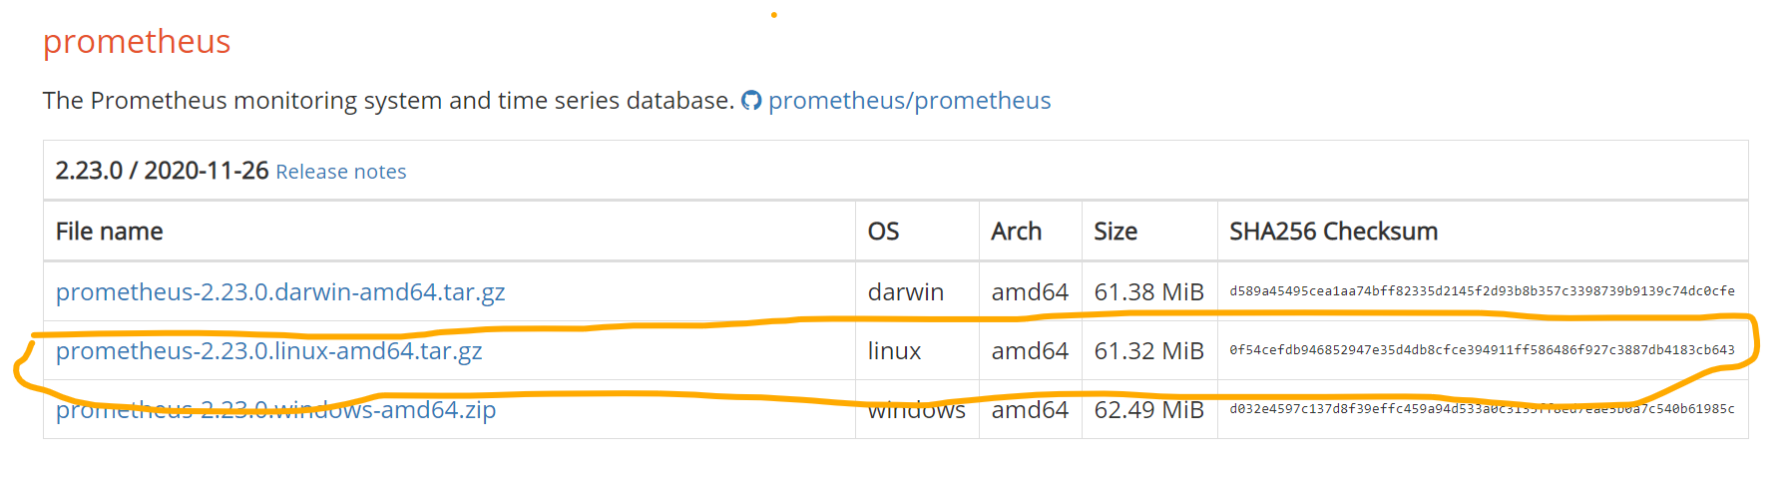

2) I have used wget to download the prometheus package in the LINUX EC2 instance.

Wget https://github.com/prometheus/prometheus/releases/download/v2.23.0/prometheus-2.23.0.linux-amd64.tar.gz

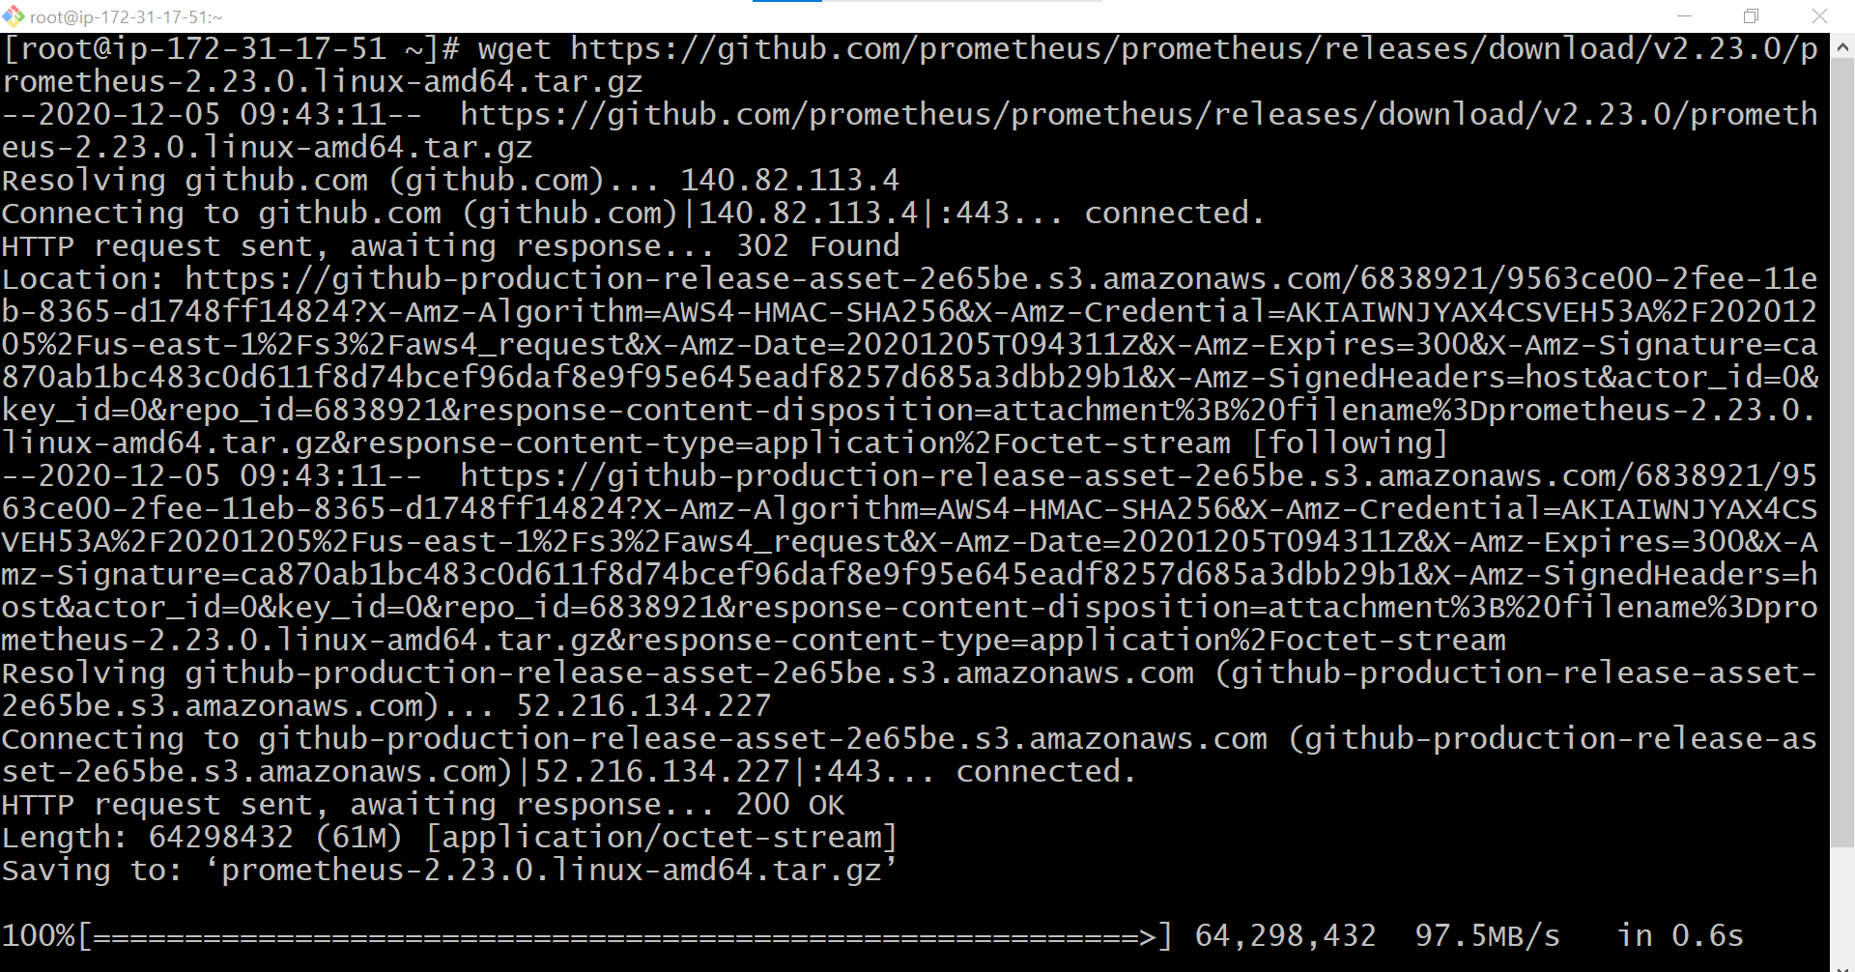

3)Enter ls



Once the archive is downloaded , Extract is using the below command.

tar -xvzf prometheus-2.23.0.linux-amd64.tar.gz

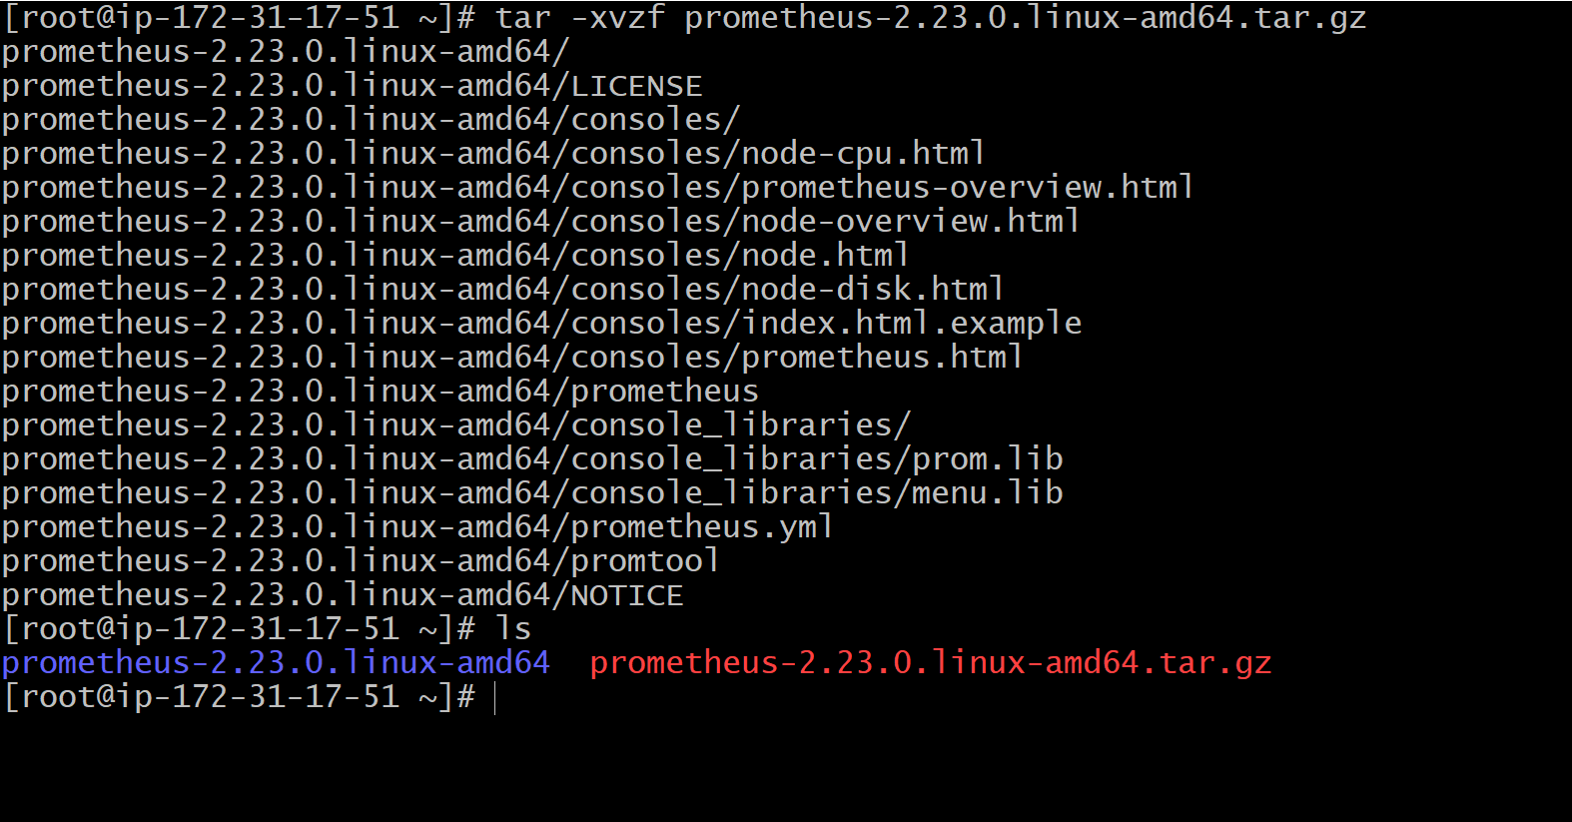

## ****Create prometheus system group****

prometheus runs with its own username and the group.

Lets create a system group named prometheus

**groupadd --system Prometheus**

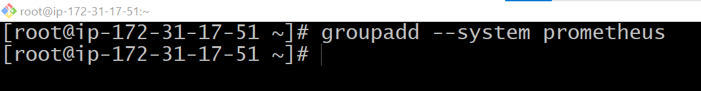

## ****Create prometheus system user****

We have created a system group for prometheus , lets create a prometheus user and add the user to the group.

**useradd -s /sbin/nologin -r -g prometheus Prometheus**

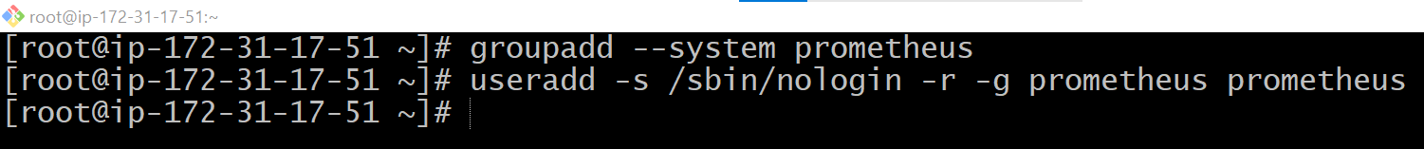

## ****Setup directories for prometheus****

We need to create separate folders to store prometheus data and the prometheus configurarion files.

**/var/lib/prometheus** – Will be used to store prometheus data

**/etc/prometheus** – will be used to store configuration files

**mkdir -p /var/lib/prometheus**

**mkdir -p /etc/prometheus**

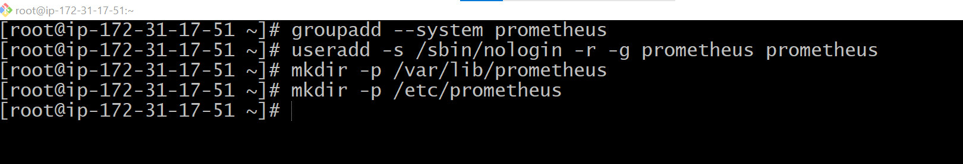

## ****Copying prometheus binary files****

We need to copy the prometheus binary files to the directory where all the user libraries will be stored.

cp prometheus-2.23.0.linux-amd64/prometheus /usr/local/bin/

cp prometheus-2.23.0.linux-amd64/promtool /usr/local/bin/

## 

## 

## ****Copying prometheus console and console libraries to the prometheus configuration directory****

Prometheus consoles files and console_libraries should be stored under /etc/prometheus directory

cp -r prometheus-2.23.0.linux-amd64/consoles /etc/prometheus/

cp -r prometheus-2.23.0.linux-amd64/console_libraries /etc/prometheus/

cp prometheus-2.23.0.linux-amd64/prometheus.yml /etc/prometheus/

## 

## 

## 

## ****Changing directory ownership****

We have created separate user and the group for the prometheus as the configuration files and the data directory should be owned by prometheus to run the prometheus service.

chown -R prometheus:prometheus /etc/prometheus/ /var/lib/prometheus/

chmod -R 775 /etc/prometheus/ /var/lib/prometheus/

## ****Setup systemd file for prometheus****

We need to create and configure systemd unit file for the us to manage the prometheus service at ease.

The name of the systemd file should end with .service and it has to be created under /etc/systemd/system directory.

**vi /etc/systemd/system/prometheus.service**

and paste the below content into the file.

[Unit]

Description=Prometheus

After=network.target

[Service]

User=prometheus

Group=prometheus

Type=simple

ExecStart=/usr/local/bin/prometheus \

--config.file /etc/prometheus/prometheus.yml \

--storage.tsdb.path /var/lib/prometheus/ \

--web.console.templates=/etc/prometheus/consoles \

--web.console.libraries=/etc/prometheus/console_libraries

[Install]

WantedBy=multi-user.target

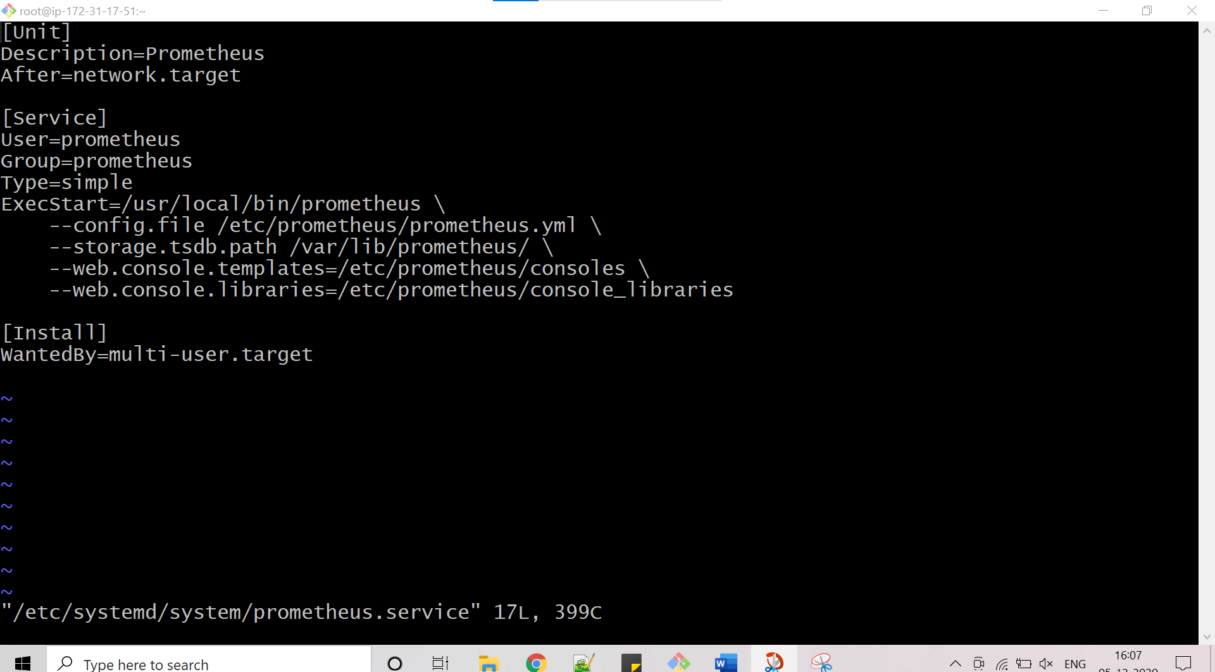

**Configuring prometheus configuration file**

The configuration file prometheus.yml is stored in /etc/prometheus directory.

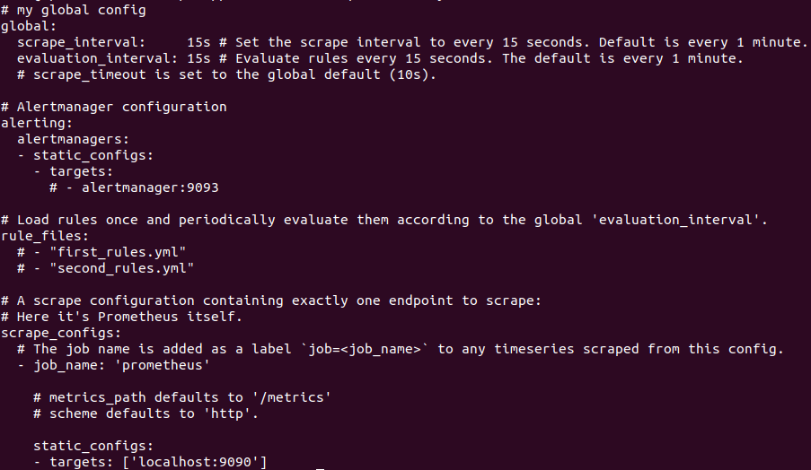

Here the target is prometheus itself.

## ****Start the prometheus service****

To start the prometheus service , run the below command.

**systemctl start prometheus**

Command to start the prometheus service on system boot

**systemctl enable prometheus**

**Created symlink /etc/systemd/system/multi-user.target.wants/prometheus.service → /etc/systemd/system/prometheus.service.**

Lets check the status of the prometheus service.

**systemctl status prometheus**

You should that the prometheus service is UP and running.

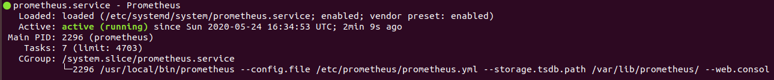

We can also check , On what port prometheus is listening.To check that , run the below command.

The prometheus service is listening on the port 9090.

**netstat -nltp |grep Prometheus**

tcp6 0 0 :::9090 :::* LISTEN 2838/prometheus

**tcp6 0 0 :::9090 :::* LISTEN 22**

Add the rule as shown below. Temporarily 9090 is allowed for public which is not recommended

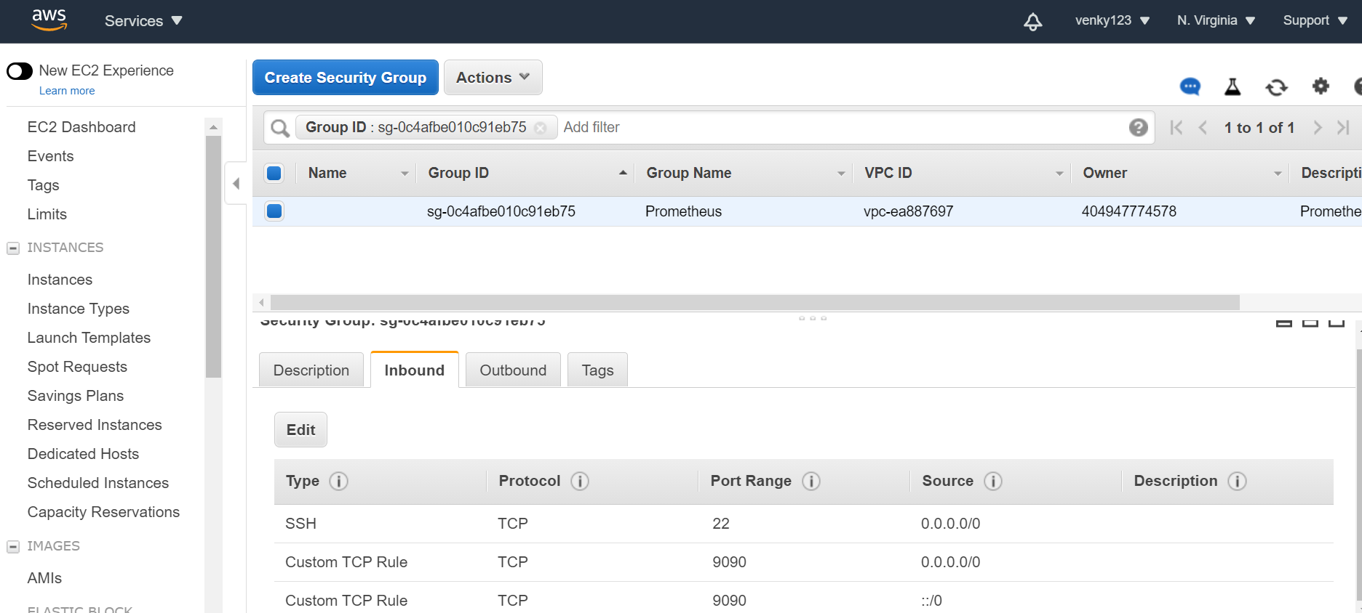

**http://publicipaddress:9090**

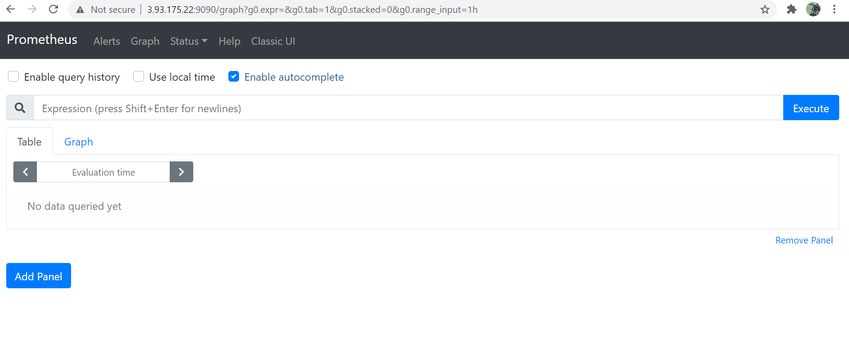

## Download and install GRAFANA

Follow the steps

LINK to Grafana downlod <https://grafana.com/docs/grafana/latest/installation/rpm/>

Or

Add a new file to your YUM repo using the method of your choice. The command below uses vi

sudo vi /etc/yum.repos.d/grafana.repo

[grafana]

name=grafana

baseurl=https://packages.grafana.com/oss/rpm

repo_gpgcheck=1

enabled=1

gpgcheck=1

gpgkey=https://packages.grafana.com/gpg.key

sslverify=1

sslcacert=/etc/pki/tls/certs/ca-bundle.crt

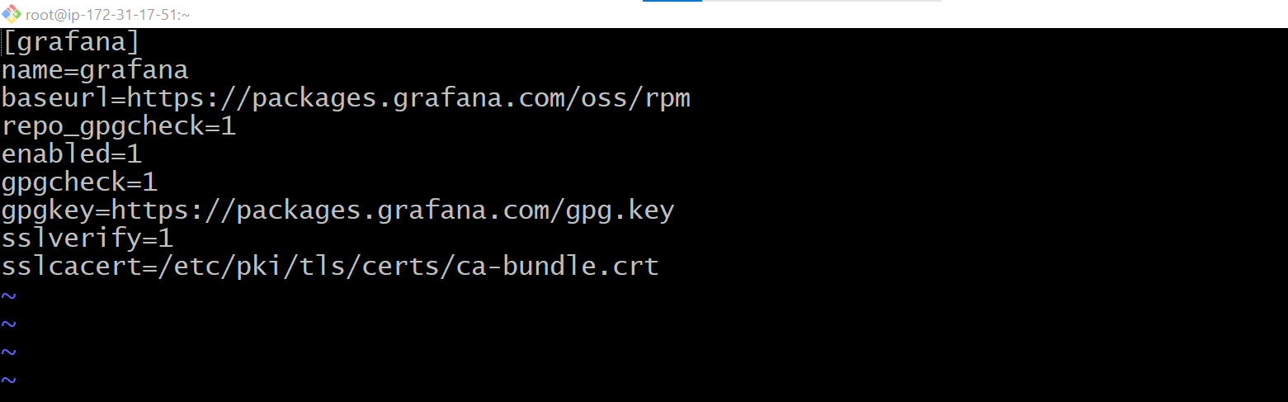

enter the below command to install grafana

sudo yum install grafana

sudo systemctl daemon-reload

sudo systemctl start grafana-server

sudo systemctl status grafana-server

Configure the Grafana server to start at boot:

sudo systemctl enable grafana-server

### **Start the server with init.d**

To start the service and verify that the service has started:

sudo service grafana-server start

sudo service grafana-server status

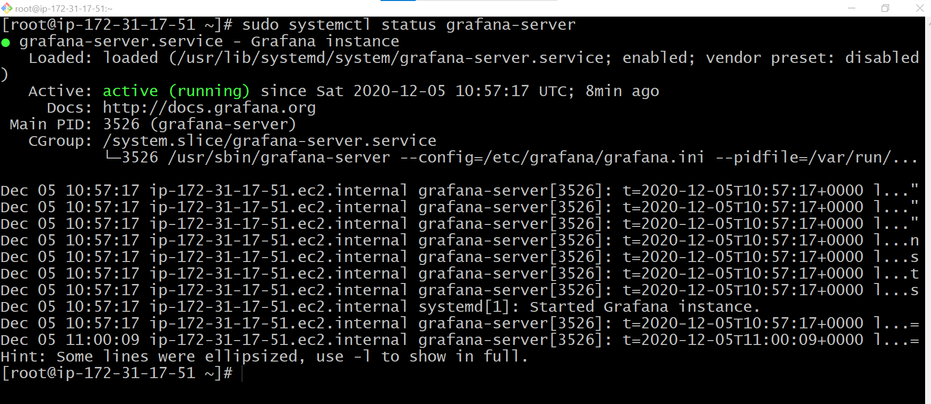

<http://publicipaddress:3000>



# **NodeExporter**

Download the latest node exporter package

curl -LO https://github.com/prometheus/node_exporter/releases/download/v0.18.1/node_exporter-0.18.1.linux-amd64.tar.gz

tar -xvf node_exporter-0.18.1.linux-amd64.tar.gz

sudo mv node_exporter-0.18.1.linux-amd64/node_exporter /usr/local/bin/

sudo useradd -rs /bin/false node_exporter

sudo vi /etc/systemd/system/node_exporter.service

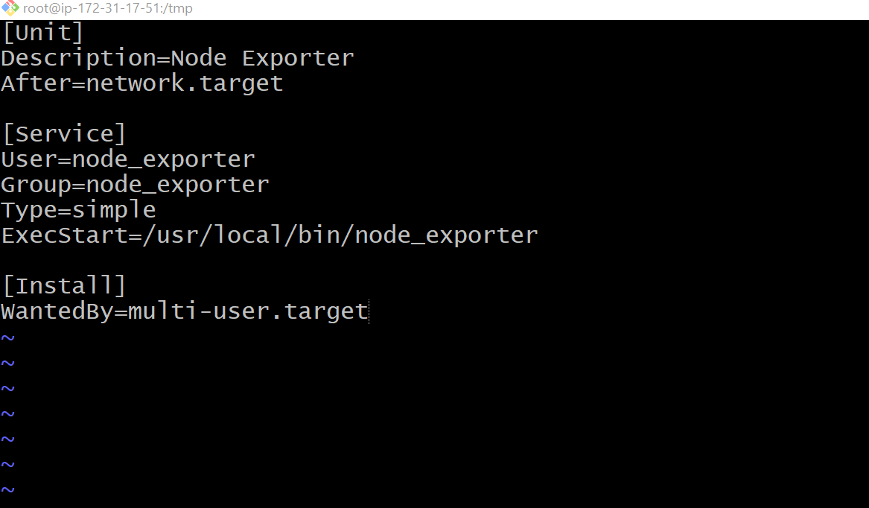

sudo systemctl daemon-reload

sudo systemctl start node_exporter

sudo systemctl status node_exporter

sudo systemctl enable node_exporter

http://<server-IP>:9100/metrics